use LibraryDB

create table EMPLOYEE(

EmployeeID int primary key,

EmpName nvarchar(20),

Phone nvarchar(12),

Email nvarchar(30)

)

create table MANUFACTURER(

MfName nvarchar(20) primary key,

City nvarchar(20),

State nvarchar(20)

)

create table COMPUTER(

SerialNumber int primary key,

MfName nvarchar(20)

foreign key references MANUFACTURER(MfName)

on delete cascade,

Model nvarchar(20),

Weight Numeric(7,2),

EmployeeID int

foreign key references EMPLOYEE(EmployeeID)

on delete cascade

)

insert into EMPLOYEE values (1,'Tom','987654321','tom123@gmail.com'),

(2,'ram','987651234','ramcom@gmail.com'),

(3,'sam','956784321','samuel@gmail.com'),

(4,'jam','987635421','jimmy@gmail.com')

insert into EMPLOYEE values (5,'Kim','978654321','kim90@gmail.com')

insert into MANUFACTURER values('Lenovo','charity','South Dakota'),

('IBM','Seattle','Washington'),

('Acer','Pierre','South Dakota'),

('Apple','Buffalo','New York'),

('Dell','Dallas','Texas')

insert into COMPUTER values(101,'Lenovo','Le345',20,1),

(102,'IBM','I45',22,2),

(103,'Acer','AC09',10,3),

(104,'Apple','AI13',18,4),

(105,'Dell','DE89',17,5)

--q1

select MfName ,State from MANUFACTURER where State='South Dakota'

--output

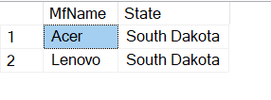

--q2

select avg(Weight) as [Average Weight] from COMPUTER

--output

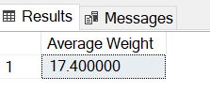

--Q3

select EmpName from EMPLOYEE where phone like '9%'

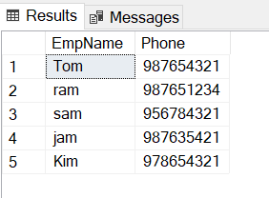

--q4

select SerialNumber from COMPUTER where Weight <

(select avg(Weight) from COMPUTER)

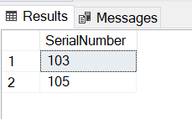

--Q5

select MfName from MANUFACTURER where MfName IN

(SELECT MfName FROM COMPUTER WHERE MfName IS NULL)

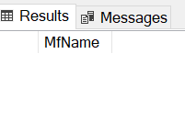

--Q6

select e.EmpName,c.SerialNumber, m.City from EMPLOYEE e

join COMPUTER c

on e.EmployeeID=c.EmployeeID

join MANUFACTURER m

on c.MfName=m.MfName

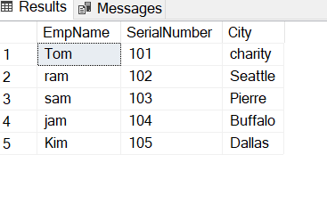

--q7

create procedure spDetails

as

begin

select c.EmployeeId,c.SerialNumber,c.MfName,c.Model,c.Weight from

COMPUTER c

end

EXEC spDetails

